

Guidelines

**Crop Production Practices Diagnostics:**

***Survey Methodology, Digital data Collection and Analysis***

*Krishi Vigyan Kendra (KVK)*





**Diagnostics of Crop Production Practices: Survey Methodology,**

**Digital Data collection** &

**Analysis**

* KVK’s are already involved in participatory agronomic research.
* CSISA will be collaborating with KVK’s for integrating CSISA’s expertise and KVK’s experience to generate key evidences at a larger scale for better programming, planning and technology targeting.
* Technology targeting basically means that conducting surveys for collecting data on the various aspects of crop-productions-practices used/adapted by the farmers.
* *The basic objective of the study is to describe*

**scientific**

**digital data collection tools** to generate

**primary-data-based results/analysis/evidences/interpretations** at a larger scale for better planning

Here “**scientific**” means using proper survey methodology i.e. scientific methods of selecting sampling units (out of the total population) on which the data would be collected. Once the sampling units has been decided, the next step would be decide on the indicators/variables on which the data would be collection. The collection of all possible indicators/variables/questions is called “Questionnaire”.

“**digital data collection tools**” means the digital means viz laptop/palmtop/Tablets/Mobiles etc. which are used to feed the responses of the sampled units (viz farmers) directly into the system in digital format (eg. An excel file).

Finally to draw **valid inferences/results/interpretations** on the basis of this sampled data, statistical tools/methods are used.

According, we have divided the contents of this manual in the following chapters.

Chapter-1: ***Introduction and Background***

Chapter-2: ***Survey Methodology***

Chapter-3: ***Designing of Questionnaire***

Chapter-4: ***Digital Data Collections tools***

Chapter-5: ***Data Analysis and Interpretation***

Chapter-1: ***Introduction and Background***:

This chapter will cover

1. *Why this document has been prepared*
2. *Who may be benefitted from this document*
3. *What improvement can be brought out in the future planning through the outputs of this Study*

Chapter-2: ***Survey Methodology***:

This Chapter deals with

1. *What is Sampling*
2. *Why Sampling*
3. *Types of Sampling*
4. *Sampling Methodology and design adopted in this study*

Chapter-3: ***Designing of Questionnaire:***

This Chapter will cover

1. *What variables/indicators are chosen for the study*
2. *What outputs are expected from these indicators*

Chapter-4: ***Digital Data Collections tools***:

This chapter will include

(i) Necessities of Digital data collection and its benefits over paper based data collection

(ii) Digital data collection tools and platforms

(iii) Complete description of Open Data Kit (ODK) – components, operational aspects, data collection, extraction, integration and data diagnostics

(iv) Digital database management (database naming convention, storage and sharing)

Chapter-5: ***Data Analysis and Interpretation***:

This chapter will elaborate

1. *Basic concepts of statistical methods and tools*
2. *Analysis of data*
3. *Interpretation of results*

***Survey***

***Methodology***

# ***2. Survey Methodology***

## ***2.1 Methods of Data Collection***

There are several methods of data collection that can be utilized for Monitoring, Learning & Evaluation (MLE). These methods fall into two broad categories:

Quantitative methods – Data are collected in a random sample of ‘observation units’, typically farm households. Random sampling is required to ensure that the sample is representative of a larger underlying population, e.g. farm households in the district. From each observation unit, the same set of information is elicited using a structured questionnaire. If the observation unit is the farm household, this means that each respondent farmer is asked exactly the same questions. Appropriate statistical methods are used for data analysis.

Example: We collect data on wheat yields from a random sample of farm households in district X. If our sample is sufficiently large, the average yield we find in our sample will be an adequate *estimate* of the average yield that farmers in district X attain overall.

Qualitative – This approach is commonly used when the research topic is complex and requires deeper understanding. Focus group discussion (FGD) and key informant interviews (KII) are some of the very popular methods to collect data. Other than in the quantitative approach, we will prepare an *interview guideline* for data collection, rather than a questionnaire with fully formulated questions and potential response options. The guideline helps us ensure that we cover all relevant aspects during the interviews/discussions, but each such event will differ from the other. For instance, when we discuss a given topic with two groups of farmers separately, the two groups will almost certainly give different kinds of reactions and inputs, leading the discussion in somewhat different directions. It is the task of the researcher to react flexibly and follow up on such diverse inputs, rather than sticking to a list of pre-defined questions, as is done in a quantitative survey.

Both quantitative and qualitative methods have their own merits and limitations. None is ‘better’ than the other; rather, the two approaches complement each other, and which of the two is more appropriate depends on the research question to be addressed. If we want to get a ‘representative’ picture of what practices farmers are using, how these technologies are performing, and what farmers’ perceptions are regarding the benefits of these practices and the constraints to their adoption, we need to use the quantitative approach. If we want to delve into great depth or get farmers’ views on sensitive or highly complex issues, or we want to investigate particularly contrasting cases/settings, we should pursue the qualitative approach. When we follow a qualitative approach, we often select the villages where we conduct FGDs or KIIs according to certain criteria, e.g. villages with good market access versus very remote villages; this means that, in contrast to the quantitative approach, we often use purposive sampling rather than random sampling to select our research villages. Findings from qualitative research *cannot* be generalized to the population, but they can be used to highlight (contrasting) cases or conditions that require further investigation. Consequently, the sample size (e.g. number of selected villages) in qualitative research is usually very small (say, not more than 10 villages).

Often, a ‘mixed-methods’ approach is recommended, combining the strengths of both quantitative and qualitative approaches. Following is an overview of the advantages and disadvantages of the two approaches.

|  |  |  |
| --- | --- | --- |
|  | **Quantitative** | **Qualitative** |
| **Advantages** | * Results can be extrapolated to a larger, underlying population * Efficient and easy digital data collection using structured questionnaire * Relatively quick basic statistical data analysis | * Information can be obtained relatively quickly and inexpensively * More suitable for sensitive or complex issues than quantitative approach * Flexibility to follow up on unexpected aspects as they arise during data collection * Useful for preceding a quantitative survey (which are the important issues to ask about?) or for following up on specific survey results in greater depth |
| **Disadvantages** | * Relatively costly and time-consuming, depending on sample size * Less suitable for sensitive or highly complex issues (e.g. power relations etc.) * Statistical data analysis requires at least minimum proficiency in using a computer (e.g. MS Excel) | * Results *cannot* be extrapolated to a larger population (e.g., each FGD represents a *case study*) * Results are easily biased by dominant FGD participants or less knowledgeable key informants * Data collection requires greater skill than applying a structured questionnaire * Proper analysis can be difficult and time-consuming |

## ***2 Random sampling***

Random sampling is a basic requirement for the quantitative approach of data collection, as is typically applied in a household survey. However, random sampling is also applicable to crop-cut surveys, as the objective is to obtain a yield estimate that is representative of the underlying population. Since random sampling is so important, in the following we will describe the steps involved in random sampling in detail, to serve as a practical guideline.

### ***2.1 Important terms and steps***

* ***Element (or observation unit)*:** This is the unit about which information is sought (e.g., a farm household).
* ***Sampling unit*:**This is the element or elements available for selection at a given stage in the sampling process. Usually, in a first stage, villages are our sampling unit, and, in a second stage, farm households are our sampling unit (see section *Sampling procedure* below)
* ***Sampling frame*:** This is the list of sampling units available for selection.
* ***Population (or universe)*:** This is the aggregate of all the elements defined prior to selection of the sample. A properly designated population must be defined in terms of (possible definitions in parentheses):
  + **Elements** (farm households)
  + **Sampling units** (villages first, then farm households, being defined as households that were involved in farming in the rabi season)
  + **Extent** (One district in UP & Bihar)
  + **Time** (Survey represents the situation after the rabi season)

Broadly speaking, the sampling process comprises the following five steps:

Step 1: Define the population, sampling units, extent and time.

Step 2: Select a sampling procedure.

Step 3: Construct the sampling frame(s) required.

Step 4: Determine the sample size.

Step 5: Select the sample.

***2.2 The simple random sample***

In the simple random sample there is only one type of sampling unit, for instance all households residing in one village. Simple random sampling is a sampling technique where every item in the population has an even chance and likelihood of being selected in the sample. Here the selection of items completely depends on chance or by probability and therefore this sampling technique is also sometimes known as a method of chances. Simple random sampling is a very basic type of sampling method and can easily be a component of a more complex sampling method. The main attribute of this sampling method is that every sample has the same probability of being chosen.

**Golden Rule in random sampling: Each and every element of the population must have the same chance of being selected!**

This means that one needs a complete list of population members, i.e. a list of all households in that one village. This is our *sampling frame*. Start compiling the household list using any exisiting list in the respective village; then update the list with the help of key informants, e.g. the village head. In larger villages, it will be best to work with key informants at hamlet level to compile the list. For the sampling to be truly random, it is important to put adequate effort into compiling a sampling frame which is as complete as possible. Remember, if the sample is not random, we cannot claim that it is representative of the underlying population.

You should end up with a list of all household heads in the village; next, number the households consecutively from 1 to ‚max‘, where ‚max‘ stands for the total number of households in the village. For example, if there are 150 households in the village, your numbers would run from 1 through 150.

### ***2.3 How to select the sample***

Open an MS Excel spreadsheet and select cell A1. Use the function ‘randbetween’ to create a random number that lies between a specified minimum and maximum. The minimum is usually ‘1’, i.e. the first element in our sampling frame. The maximum depends on the number of elements in our list. In our example it is 150; we therefore type:

=randbetween (1,150) and press Enter.

Assume you want to select 10 households randomly: select cell A1, click on the lower right corner of cell A1 and drag it down until you reach cell A10. You now have a list of 10 random numbers available, which all lie between 1 and 150. Now simply copy the random numbers and paste them in column B as values. Do not worry if the random numbers in column A change in the process. The numbers in column B are now what matters. In your sampling frame (the list of numbered names of household heads), now tick off all the households that have been selected according to the list of random numbers. Maybe you now find that a household is selected more than once; for example, maybe number ‘18’ appears more than once in your list of random numbers. In this case, go back to cell A1 and generate a new random number by pressing the key F9. Press F9 until you get a random number in cell A1 which you haven’t already ticked off in your household list. Paste this number (as value) in the respective cell of column B as replacement of the original number. Tick off the respective household in your sampling frame. Continue this process until you have selected a total of 10 households.

*Important notes*

* Never discard a list of random numbers because you think the numbers ‘don’t look random’. This would nullify the idea of randomization. Always use the first numbers you get, replacing only duplicates in the way described above.
* Practically, it may happen that a few of the randomly selected households/respondents are either no farmers or are very difficult to get hold of to collect their data. Try to get their mobile number and make an appointment. If you REALLY cannot get hold of a respondent (for example, because he/she is out of the village for an extended period), it is permissible to RANDOMLY select a *replacement household*. For practical purposes, when you do the random selection of your respondent households, select an extra 50% as random replacements. In our example of 10 respondent households above, you would select an extra 5 households which would ONLY be interviewed if some of the original respondents really couldn’t be found. To do this systematically, for the first respondent household that drops out, use the replacement household with the smallest random number, then the one with the next larger random number etc.

Advantages of Simple Random Sampling

1. It is a fair method of sampling and if applied appropriately it helps to reduce any bias involved as compared to any other sampling method involved.

2. Since it involves a large sample frame it is usually easy to pick smaller sample size from the existing larger population.

3. The person who is conducting the research doesn’t need to have a prior knowledge of the data being collected. One can simply ask a question to gather the researcher need not be a subject expert.

4. This sampling method is a very basic method of collecting the data. There is no technical knowledge required and need basic listening and recording skills.

5. Since the population size is large in this type of sampling method there is no restriction on the sample size that needs to be created. From a larger population, you can get a small sample quite easily.

6. The data collected through this sampling method is well informed, more the samples better is the quality of the data.

**Disadvantages of Simple Random Sampling**

1. It is a costlier method of sampling as it requires a complete list of all potential respondents to be available beforehand.

2. This sampling method is not suitable for studies involving face-to-face interviews as covering large geographical areas have cost and time constraints.

3. A sample size that is too large is also problematic since every member of the population has an equal chance of selection. The larger population means a larger sample frame. It is difficult to manage the large population.

4. The quality of the data depends on the researcher and his/her perspective. If the researcher is experienced then there are fair chances the quality of data collected is of a superior quality. But if the researcher is inexperienced then the data collected may or may not be upto the mark.

## ***3 Cluster sampling***

Cluster sampling is defined as a sampling method where multiple clusters of people are created from a population where they are indicative of homogeneous characteristics and have an equal chance of being a part of the sample. In this sampling method, a simple random sample is created from the different clusters in the population.

Usually, when we conduct a household survey, we want to be able to extrapolate our findings to a much larger population than in the example above (where our population comprised all households in one village only). As a KVK, you will want to make statements about farmers’ practices in your entire district. If we had a list of ALL households in the district, we could theoretically apply the simple random sampling approach described above. But there are two problems: (1) practically, it’s not possible to prepare such a list which would likely comprise tens of thousands of households; (2) if we were to select a simple random sample from this (hypothetical) list, we would likely end up with a sample of households dispersed across a large number of villages, with possibly just a single household randomly selected per village; this would make data collection extremely expensive and time-consuming.

To circumvent these practical constraints, we apply *cluster sampling* as our standard approach to selecting a random sample of households among a larger population. Cluster sampling encompasses two stages:

* **1st stage:** from a list of ALL villages in your district, randomly select an appropriate number of research villages.
* **2nd stage:** within the randomly selected research villages, randomly select an appropriate number of respondent households, as described in section 4.2.3 above.

What numbers are ‘appropriate’ is discussed in section 4.4 below. This two-stage approach has the advantage that you require a household-level sampling frame for the selected villages only; furthermore, it ensures that survey respondents are clustered within a limited number of villages, making data collection much more efficient.

It may be that a new technology/practice has been promoted in a limited number of blocks within your district only. In this case, you would apply the cluster sampling procedure to the target blocks only, i.e., in stage 1 you would randomly select villages from a list of ALL villages in the target blocks. However, when you interpret the results, you must keep in mind which blocks comprise the population; you cannot state that your findings are representative of your entire district since it may well be that the target blocks differ systematically from the remaining blocks in your district. For instance, initial target blocks may have been more easily accessible than non-target blocks, which may at the same time mean that farmers in these blocks have, on the average, better access to agricultural inputs and agriculture related information; this, in turn, may have repercussions on their willingness and ability to adopt the new practice which was the subject of your assessment.

**4. Determining the sample size**

There are ways to calculate the sample size required for a pre-specified level of precision of a key variable of interest: for instance, you may want to be able to state that, with a probability of 95%, the average wheat yield according to your random sample (the *sample mean* in kg per ha) lies within a range of 200 kg around the true average wheat yield attained by farmers in your district (the *population mean*). These kinds of calculations are beyond the scope of this document. Rather, in the following, we present some general considerations about sample size and deduce concrete recommendations for application by ATARIs and KVKs.

The larger the sample size, the more precise our *estimates* will be, such as average yields or the percentage of farmers using a given technology. In other words, with a larger sample, we can be more confident that our results will be relatively close to what we would find in the population as a whole. Related to this, the larger the sample size, the more likely we are to detect statistically significant differences between groups (e.g., differences in wheat yields between farmers who sowed before November 15 and those who sowed thereafter). However, the gains in precision decrease quickly at the margin with increasing sample size.

**We suggest that KVKs aim at a sample size of 300 randomly selected farm households in their district** to assess farmers’ current practices; for most purposes, this sample size achieves a good balance between data precision on the one hand and cost of data collection on the other. We further suggest that sample households be **spread across 30 randomly selected villages** to capture an adequate degree of across-village variation, e.g. in terms soil conditions, infrastructure, and market access (factors which may influence the outcomes that we’re interested in).

### **4.1 Accounting for differences in the size of selected villages**

In stage 1 of the cluster sampling procedure, if we use simple random sampling for the selection of research villages from a list of all villages in your district, each village will have the same chance of being randomly selected, irrespective of its size in terms of resident households.

In stage 2 of the cluster sampling procedure, **we would then need** **to adapt the number of households to be selected to the size of the village** to fulfil the **Golden Rule** in random sampling(i.e., each and every element of the population must have the same chance of being selected). Why? Suppose that we selected two villages randomly, village A comprising 200 households and village B comprising 800 households. If we wanted to select a total of 40 households and selected 20 households per village, the chance of each household to be selected would be 20/200 = 0.1 (10%) in village A and 20/800 = 0.025 (2.5%) in village B, hence violating the Golden Rule. We could select a proportionate number of households by calculating weighting factors for each village, as the number of households in this village divided by the number of households in all selected villages combined: for village A this would be 200/1000 = 0.2 and for village B it would be 800/1000 = 0.8. We could then multiply the weighting factors with the total sample size to derive the number of households to be selected in each village: for village A this would be 40 * 0.2 = 8 and for village B it would be 40 * 0.8 = 32. With this correction, the chance of a household to be selected in village A would be 8/200 = 0.04 (4%) and in village B it would be 32/800 = 0.04 (4%), hence fulfilling the Golden Rule.

### ***4.2 The PPS procedure***

The simple random sampling scheme provides a random sample where every unit in the population has equal probability of selection. Under certain circumstances, more efficient estimators are obtained by assigning unequal probabilities of selection to the units in the population. This type of sampling is known as varying probability sampling scheme. Probability proportional to size (PPS) refers to a sampling technique where the probability that a particular sampling unit will be chosen in the sample is proportional to some known variable such as population size or geographic size. If Y is the variable under study and X is an auxiliary variable related to Y, then in the most commonly used varying probability scheme, the units are selected with probability proportional to the value of X, called as size. This is termed as probability proportional to a given measure of size (pps) sampling. If the sampling units vary considerably in size, then SRS does not takes into account the possible importance of the larger units in the population. A large unit, i.e., a unit with large value of Y contributes more to the population total than the units with smaller values, so it is natural to expect that a selection scheme which assigns more probability of inclusion in a sample to the larger units than to the smaller units would provide more efficient estimators than the estimators which provide equal probability to all the units. This is accomplished through pps sampling.

PPS is usually used in multi-stage cluster (or stratified) sampling for population-level studies. It can also be called “unequal probability sampling” because you are actually increasing the odds that a subject will be chosen in the sample based on its size. PPS is used when the populations of sampling units vary in size. If the sampling units are selected with equal probability, then the likelihood of a sampling unit with a large population being selected for the survey is actually less than the likelihood of elements from a sampling unit with a small population being selected. PPS reduces standard error and bias by increasing the likelihood that a sampling unit from a larger population will be chosen over a sampling unit from a smaller population. This can also be done after the sample is complete by using weighting techniques, but using PPS instead of weighting allows you to do your calculations up front, before sample selection, as opposed to having to do your calculations during analysis. If you use PPS, you can completely avoid having to do weighting later in the process.

If updated information about the number of resident households in each village is available in the sampling frame, **probability-proportionate-to-size (PPS) selection can be used in stage 1, which allows the selection of an equal number of households per village in stage 2**. Due to advantages regarding logistics and data analysis, **PPS is the preferred method**. For instance, given the suggested sample size of 10 households (HHs) per village, a team of two people would likely be able to complete the interviews in one day and then move on to the next village. If sample sizes vary between villages, data collection would be less efficient to organize. To illustrate the PPS method, consider the example of four villages of varying sizes given in the table below:

|  |  |  |  |  |
| --- | --- | --- | --- | --- |
| **Village name** | **Number of households (HHs)** | **Cumulative number of HHs** | **HH ID range** | **Probability of selection** |
| A | 200 | 200 | 1 -200 | 200/1000 = 20% |
| B | 300 | 500 | 201 – 500 | 300/1000 = 30% |
| C | 100 | 600 | 501 – 600 | 100/1000 = 10% |
| D | 400 | 1000 | 601 – 1000 | 400/1000 = 40% |

To select villages using the PPS method, we generate random numbers within the range 1 – max. HH ID. In the example above, we would type the formula =randbetween(1, 1000) into Excel; **a village is selected if the random number falls within its HH ID range,** thus making the probability of its selection proportionate to its size. For example, the random number 461 would fall into village B (HH ID range 201 – 500); hence, village B would be selected. We would continue generating random numbers (pressing the F9 key) until the desired number of villages is selected. If a random number falls within an already selected village, we simply continue pressing F9 until we get a random number that falls within a new village.

The PPS method for selection of villages can be done based on the 2011 census data which contain the number of resident households in each village of a given district. While the number of households has likely grown since 2011, this does not cause a problem as population growth has likely been relatively similar across the villages of a given district; hence the relative size of villages is likely to stay more or less the same, which is what matters for the PPS method to work as intended.

As village selection using the PPS method requires the handling of relatively large census datasets and the calculation of cumulative numbers of households and ID ranges, we suggest that the village selection be done at ATARI level.

## ***2.5 Suggested Sampling Procedure***

In summary, we suggest the following cluster sampling procedure to be followed by ATARIs and KVKs, which includes practical considerations for reducing the workload while maintaining scientific rigour:

1. ATARIs:Using the 2011 census data of the districts in your area of operation, select 30 villages randomly per district, applying the PPS method as described in section 2.4.2. Send the lists of selected villages to the respective KVKs. The selected villages can be used for three consecutive surveys; for the fourth survey, select a new sample of 30 villages per district; in case one of the previous villages is again randomly selected, discard this village and select a random replacement.
2. KVKs:

* For the selected villages, compile household (HH) lists which are as complete as practically possible. To complete the household listing following steps will be followed:
  + ATARI director issues a formal letter to the District Magistrate to share the information of upgraded household list of the selected villages.
  + Respective district’s KVK PC will follow-up and coordinate with concerned district administration and departments to upgrade and complete the selected village’s household listing.
* Where there is not upgraded and complete household listing, one could start with any existing list and then update it with key informants at hamlet level where resident HHs should be well-known.
* In villages > 500 HHs, randomly select a number of hamlets for the HH listing, using the ‘randbetween’ formula in MS Excel, as described in section 4.2.3 (the maximum value to be entered equals the number of hamlets in the village). The number of hamlets should be chosen such that the total number of HHs to be listed is < 500; in any case, more than one hamlet should be randomly selected.
* Once the listing is completed for a village, randomly select 10 HHs for data collection using the ‘randbetween’ formula in MS Excel, as described in section 4.2.3 (the maximum value to be entered equals the number of HHs on the list). Select another 5 HHs randomly to be used as replacements if – and only if – an original sample HH turns out to not be involved in farming, refuses to collaborate, or is not available to be interviewed even after several attempts have been made.
* In each village, make use of the compiled HH list for three consecutive surveys, selecting a new random sample of HHs each time. This reduces the workload, but by selecting a new sample each time, possible bias in the data is avoided (the survey itself may have made interviewed HHs more aware of new practices etc.). This means, after the first survey, delete the selected HHs from the household list; for the next survey, randomly select HHs from the remaining list; follow the same procedure for a third survey.
* For the fourth survey, your ATARI will send you a new list of 30 villages to start the procedure anew.

**Random Sampling of Villages in a District**

Method:– Probability Proportional to Size (of Village)

Number of villages to be selected per district:– 30 + 5

Reference data:– District Census Data

Steps:

1. From census data sheet of the district, extract desired information as below

|  |  |  |  |
| --- | --- | --- | --- |
| **DISTRICT** | **SUB-DISTRICT** | **VILLAGE** | **No_HH** |
|  |  |  |  |
|  |  |  |  |

1. Insert a **Serial Number Column** before district and number it starting from 1 downward
2. Add another column next to No_HH column for cumulative **number of households,** check thatlast figure in this column match with total number of households in the district
3. Add two more columns next to cumulative column related to No_HH, it is range of households; first column is the lower value and second column is the high value for assigning number to each households in the district, check thatlast figure in this column match with total number of households in the district
4. Select actual No_HH column and look for **SUM,** total number of households in the district
5. Put cursor in any blank cell to use command, **=RANDBETWEEN** (1,TOTAL HOUSEHOLD); for e.g. in Kushinagar (1,533834)
6. Press **ENTER,** it generates for you the first random household number.
7. Look at the two range columns and find in which row this random value falls.
8. Highlight that village name **YELLOW** and mark it as 1, it is your first selected village
9. Go to the cell where RANDBETWEEN formula is functional & PRESS F9
10. It would give you another random number, accordingly highlight another village and mark it as your second selected village
11. Repeat the exercise till you select 35 villages
12. If you end up getting already selected village, press **F9** and keep moving
13. **Sort** village column by highlighted colour and copy 35 selected villages on another sheet with following columns – Sr_No, DISTRICT, SUB-DISTRICT and No_HH.

**Random Sampling of Households in a Village**

Method:– Probability Proportional to Size (of Village)

Number of villages to be selected per district:– 7+8

Reference data:– State Election Commission

Steps:

1. Open an excel file with two rough sheets, which would be used in generating random samples.
2. Browse <http://sec.bihar.gov.in/SearchInFinalPdf.aspx>
3. Go to the panchayat voter list tab and select the randomized district from drop down menu,
4. Now select the block from dropdown menu and the panchayat corresponding to the selected village.
5. Download ward wise village list
6. Open the downloaded pdf file (Always open it with adobe reader)
7. Copy all data from the pdf file using command **Ctrl+A** followed by **Ctrl+C**
8. Paste the copied data in first cell of the first column of the excel sheet using command **Ctrl+V**.
9. Select the first 68 rows for Bihar and 57 rows for UP and delete them
10. In the first column, go to 1st cell (A1) and use command **Ctrl+Shift+down** arrow, to select the entire set of data.
11. Go to the data tab in the excel ribbon, and select the **text to columns** option.
12. In the data type select **Delimited** and move further by selecting **Next.** In the next page under the delimiters options, select other and mention **‘ :’** inthe space provided and press finish. Your data is now segregated into two columns.
13. Set the filter at the 1st cell of column 1 (A1). Set filter and deselect all the elements first, then select ‘ **रकपन सपखनप ‘** for UP and ‘ **गतह सपखयच ‘** for Bihar**.**
14. Copy the filtered data from the second column (column B) and paste it in sheet 2. Select the data pasted in the sheet two by using command **Ctrl+Shift+down arrow.** Go to the data tab in the ribbon and select **Remove Duplicates.** This will remove all the duplicate values keeping the unique values intact.
15. Now open a new sheet in the same workbook and name it with the concerned village name. The format to be used for the sheet is given below-

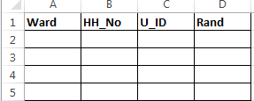

* Ward - Ward No
* HH_No - Household Number
* U_ID – Unique ID
* Rand- Random Number

1. Copy the unique values from sheet 2 and paste it in the HH_No column. Assign W1 corresponding to all the household numbers in the ward column.
2. Repeat the same procedure for the other wards of the village and name the households under ward column with W2 for 2nd ward and W3 for 3rd ward and so on.
3. When you are done with all the wards, assign a unique id for each household in the Rand column from 1 to the total no. of households.
4. Under the Rand column in cell no. 2 use command **randbetween(1, max of U_ID),** this will generate a random number**,** copy the cell and paste it up to 16th column to generate 15 random numbers. Copy the random numbers and paste it using paste special (values) in the same columns
5. The households and wards corresponding to the generated random numbers are to be surveyed.

**Selection of Farmer followed by Plot for Crop-cut**

Steps:

1. Refer to the selected 7 households in this village
2. Select the farmer whom you meet first out of these selected 7
3. Ask him for his largest wheat plot – consider this largest plot for crop-cut
4. Take farmer’s consent for crop-cut
5. Crop-cut has to be taken from 2 spots in the selected largest plot
6. Size of each of these 2 spots (quadrants) are 2m X 2m
7. Get on the corner of the plot, move diagonally for almost 5 meters and select your first spot here for taking samples
8. Similarly, repeat the procedure from the another corner of this plot and mark second spot
9. Finish crop-cut from these two spots and record

* Total above ground biomass
* Grain weight and
* moisture percent

1. Use Open Data Kit (ODK) Form – ‘Crop Cut Form’ to enter these readings along with other basic information asked in this form

***Survey***

***Questionnaire***

***Designing***

***Crop Yield* *Production Practices: Survey Questionnaire***

In the previous chapter, we have discussed about the process of scientifically selecting the farmers to be surveyed. Once, the farmers have been selected, the next task is to decide upon the questions to be asked/ the information to be gathered. The table, placed below, depicts in nut-shell the information/questionnaire scheduling.

Questionnaire Schedule in nut-shell:

|  |  |  |
| --- | --- | --- |
| SN | **Broad classification of the questionnaire topic** | *Details of the information to be asked* |
| 1. | **General Information on farmer** | *Location (eat/long)* |
| *Contact* |
| *Crop & session etc.* |
| 2. | **CROP-cutting-data** | *OPTIONAL* |
| 3. | **Land holding** | *Land size in acres* |
| 4. | **Production Practices** | *Site Characteristics (Soil type)* |
| *Crop establishment (land preparation method Crop vanity used. Crop establishment method date of sowing seed source)* |
| 5. | **Fertility Management** | *Quantity of different fertilizers v 13 14, P.K, Zuni, Gipson etc. applied)* |
| *Soil nutrient status (i.e. soil health card)* |
| *Sources of fertilizers* |
| *Irrigation details* |
| *Production Constraints (drought, flood, insect, weed)* |
| *Weed Control used (i.e. Herbicide used)* |
| *Weed Identification (i.e. top 5/10 weeds found)* |
| 6. | **Harvesting details** | *Method of harvest yield of grain in kg’s price given at farmers gate* |
| 7. | **House hold economics and Market information** | *Number of family members engaged in farming* |
| *Income from any other source* |
| *Income from agriculture* |
| *Market selling price of product (grain)* |
| *Distance to market* |
| 8. | **New technology/practices used by farmers, if any or Technology tracking** |  |

***The detailed topic wise questionnaire are presented below:***

**Note: Unless otherwise indicated, all responses correspond to information from the largest plot on each farm**

1. **Crop, season, contact and location information**

|  |  |  |  |  |
| --- | --- | --- | --- | --- |
| Country | **DROP-DOWN**: India; Bangladesh, Nepal | | | |
| State, province, or division | **India**: UP; Bihar; Odisha; West Bengal; Andhra Pradesh; Chattisgarh.  **Nepal**: State 1; State 2; State 3; State 4; State 5; State 6; State 7.  **Bangladesh**: Barisal; Dinajpur; Faridpur; Jessore | | | |
| District | Based on state selection | | | |
| Select block / mandal / updazila / rural municipality | Drop down based on district selection | Village | |  |
| CC Unit No (for AP only) |  | Unit of insurance | | for AP only |
| Survey number (for AP only) |  | No of fields in survey/sub-division (for AP) | |  |
| Farmer’s name (based on Aadhar for India) |  | Farmer’s gender | | Male; Female |
| Education level of farmer | **DROP-DOWN**: noSchooling; primary; matriculation; seniorSecondary; bachelors; masters; phD | Aadhar no (for India only) | |  |
| Social category (for India only) | **DROP-DOWN**: SC; ST; OBC; General; Other | Cell phone number | |  |
| **Bihar**: Begusarai; Khagaria; Bhagalpur; Munger; Lakhisarai; Samastipur; Muzaffarpur; Vaishali; Banka; East Champaran; West Champaran; Seohar; Gopalganj; Saran; Patna; Nalanda; Jahanbad; Gaya; Katihar; Poornia; Saharsa; Madhepura; Araria; Arwal; Supaul; Bhojpur; Buxar; Rohtas; Kaimur; Siwan; Aurangabad  **Chattisgarh**: Raipur, Mahasamund  **UP**: Mau; Balia; Gazipur; Chandauli; Deoria; Kushinagar; Gorakhpur; Maharajganj; Siddarthnagar  **WB**: Kooch Behar, Hugly, Medinipur  **Odisha:** Bhadrak; Balasore; Cuttack; Jagatsinghpur; Keonjhar; Khordha; Mayurbhanj; Puri  **Nepal:** Banke; Bardiya; Kailali; Kanchanpur; Nawalparasi; Rupandehi; Kapilbastu; Bara; Parsa; Chitwan; Dhanusha; Mahottari; Sarlahi; Saptari; Siraha; Rautahat; Morang; Sunsari; Jhapa  **AP:** Srikakulam; Vizianagaram; Visakhapatnam; East Godavari; West Godavari; Krishna; Guntur; Prakasam; Kurnool; Anantapur; Kadapa; Chittoor; Nellore  **Bangladesh**: Barisal; Bhola; Borgona; Jhalokati; Pirojpur; Potuakhali; Dinajpur; Lalmonirhat; Nilphamari; Rongpur; Thakurgaon; Faridpur; Gopalgonj; Madaripur; Rajbari; Bagerhat; Chuadanga; Jessore; Jhenaidah; Khulna; Magura; Meherpur; Narail; Shatkhira | | | | |
| Select the crop for the survey (single select) [Wheat is not applicable for AP] | **DROP-DOWN:** Rice; Wheat; Maize; Cotton; Groundnut | | <Crop>Select the season | **DROP-DOWN**: Kharif; Rabi; Aman; Aus; Boro |
| Select the year in which crop was harvested | **DROP-DOWN**: 2017; 2018; 2019; 2020; 2021; 2022; 2023; 2024; 2025 | |  |  |

1. **Crop cut** (**Optional module**) (*typically conducted for 10 – 15% of total survey respondents to verify self-reported productivity values*); *quadrants should be placed randomly within plot to ensure a representative sample.*

**Are you going to record data for (a) general crop-cuts and production survey (b) Data for treatments (Zn treated and NOT Zn treated): (For AP only)**

**If (a) i.e., general crop cuts and production practice survey, then please take the crop cuts data in the below table:**

|  |  |  |  |
| --- | --- | --- | --- |
|  | 1st quadrant [2 m x 2 m] | 2nd quadrant [2 m x 2 m] | 3rd quadrant [2 m x 2 m]  (**NOT for INDIA**) |
| Total above ground biomass – fresh weight (kg) |  |  | (**NOT for INDIA**) |
| Grain weight (kg) |  |  | (**NOT for INDIA**) |
| Grain moisture content (%) |  |  | (**NOT for INDIA**) |

**If (b) or Zn treatment data (Zn treated plots Vs Zn non-treated plots data):**

|  |  |  |  |  |
| --- | --- | --- | --- | --- |
|  | Zinc treated plot | | Zinc NOT treated plot | |
| 1st quadrant [2 m x 2 m] | 2nd quadrant [2 m x 2 m] | 1st quadrant [2 m x 2 m] | 2nd quadrant [2 m x 2 m] |
| Total above ground biomass – fresh weight (kg) |  |  |  |  |
| Grain weight (kg) |  |  |  |  |
| Grain moisture content (%) |  |  |  |  |

1. **Landholding characteristics**

|  |  |  |  |
| --- | --- | --- | --- |
| Local land unit name | Acre; Bigha; Decimal; Dhur; Kattha | One acre equals how many LLU? | ……….LLU |
| Total area of operational land during this surveyedseason (*owned and leased*) in local land units (LLU) | …………...LLU | Total [surveyed crop] area cultivated in current season | …………..LLU  Auto calculated in acre ( area * LLU) |
| Area of the largest [surveyed crop] plot  Auto calculated in acre ( area * LLU) | …………...LLU | Is the largest [surveyed crop] plot leased or owned? | **DROP-DOWN**: Owned; Leased; Farmed contract |

1. **Production practices**

**4.1 Site characteristics and crop establishment for largest [surveyed crop] plot**

|  |  |  |  |
| --- | --- | --- | --- |
| Soil texture | DROP DOWN: Light; Medium; Heavy | Drainage class | DROP DOWN: Upland; Medium-land; Lowland; Very lowland |
| Farmer perception of soil quality | DROP DOWN: High; Medium; Low | Previous crop cultivated just before [surveyed crop] in this plot | DROP DOWN: Rice; Wheat; Mungbean; Maize; Indian Mustard; Soybean; Vegetables; Cotton; Payy, Jowar, Bajra, Blackgram, greeen gran, red gram, Groundnuts, sunflower, caster, Sugarcane, Chilli, turmeric, Other[specify] |
| What was the previous crop tillage type? (multiple select) | **DROP DOWN:** Puddling (wet tillage); Disc harrow; Tyne cultivator; 4-wheel tractor rotavator; 2-wheel tractor rotavator; Bullock-drawn plough; Strip tillage; No tillage; Others[Specify] *all other possible options / combinations from above to be included in OTHERS* [multiple select] | Approximate previous crop harvest date [MM/DD/YY] |  |
| What percentage of residue was retained from previous crop? | **DROP DOWN**: 0, 5, 10, 20, 40, 60, 80, 100 | Were previous crop residue burned in the field? | Yes; No |
| [surveyed crop] variety | **DROP DOWN:** Improved variety; Local variety; Hybrid; Bt; Unknown; | [surveyed crop] variety name | DROP DOWN: [Specify]. |
| Land preparation method (applicable for the crop selected) | **DROP DOWN:** Tyne cultivator; Disc harrow; 4-wheel tractor rotavator; 2-wheel tractor rotavator; Bullock-drawn plough; Strip tillage; No tillage (multiple select) | If tillage by rotavator, number of years of continuous use | 1; 2; 3; 4; 5; 6; 7; 8; 9; 10 |
| Crop establishment method | **DROP DOWN:**  **For Rice:**  Manual puddled transplanted (Random); Manual puddled transplanted in line; Direct sown by broadcast method; Directly sown by seed drill; Beushening method; Machine transplanted in puddled soil; machine transplanted in non-puddled soil; Others [Specify]  **For Wheat:**  Broadcasting; Line sowing after tillage; Zero tillage; Surface seeding  **For Maize / Cotton / Groundnut:**  Broadcasting; Manual line sowing; Seed drills; others (specify) | <Rice> If transplanted, nursery establishment date [MM/DD/YY] |  |
| Date of crop seeding / transplanting / direct sowing (DSR Rice) / sowing (wheat) | [MM/DD/YY] | <Wheat> If wheat planting was delayed past November 30th, why? | CHECK BOX (check all that apply): Rice harvested late; Land too wet for ploughing; Non-availability of tillage equipment; Non-availability of seed; Non-availability of fertilizers; Labor shortage; Lack of moisture at sowing; Lack of funds; Other (name) |
| <Wheat> If wheat planting is commonly delayed past November 30th in most years, why? | **CHECK BOX (check all that apply):** Rice harvested late; Land too wet for ploughing; Non-availability of tillage equipment; Non-availability of seed; Non-availability of fertilizers; Labor shortage; Lack of moisture at sowing; Lack of funds Other (name) | <Rice> If transplanted system, timing of rice nursery establishment determined by: | CHECK BOX (check all that apply): calendar date; arrival of pre-monsoon showers; irrigation water availability; weather forecast information; practices of neighbouring farmers |
| <Rice> If transplanted system, timing of rice transplanting in main field determined by: | **CHECK BOX (check all that apply):** calendar date; seedling age; arrival of rains; irrigation water availability; labor availability | Crop seed amount used in KG |  |
| **[**surveyed crop**]** **Source of seed** | **DROP DOWN:** Self-saved; Neighbor or Relative; Private seed dealer; Cooperative; Government/KVK/SAU  Other (specify) |  |  |

* 1. **Fertility management in largest [surveyed crop] plot**

|  |  |  |  |  |  |  |  |
| --- | --- | --- | --- | --- | --- | --- | --- |
| Was organic compost (‘FYM’) applied? | **DROP DOWN:** Yes; No | | If ‘yes’, type of FYM | | **DROP DOWN:** Dry; Wet | | |
| Total compost applied in KG | …………KG | |  | |  | | |
| Did you apply mineral fertilizer in this plot? | | | | | **DROP DOWN:** Yes; No | | |
| Soil health card (SHC) status of this plot [Nutrients list] | | | | | **DROP DOWN:** High; Average; Low; No SHC; Soil health card available but information not used | | |
| Total DAP applied (kg) | |  | Price (Rs/kg) | | (Not for INDIA) | | |
| Total NPK applied (kg) | |  | Price (Rs/kg) | | (Not for INDIA) | | |
| Total Urea applied (kg) | |  | Price (Rs/kg) | | (Not for INDIA) | | |
| Total MoP applied | |  | Price (Rs/kg) | | (Not for INDIA) | | |
| Total Zinc Sulfate (kg) | |  | Price (Rs/kg) | | (Not for INDIA) | | |
| Total Gypsum (kg) | |  | Price (Rs/kg) | | (Not for INDIA) | | |
| Total Boron (kg) | |  | Price (Rs/kg) | | (Not for INDIA) | | |
| Did you apply any other fertilizers apart from above? | Yes – No | If yes; name(select) | **DROP DOWN:** NPKS; SSP; TSP; Other (Specify): | Total Amount (kg) |  | Price (Rs/kg) | (Not for INDIA) |

* 1. **Detailed fertility management for largest [surveyed crop] plot**

|  |  |  |  |  |  |  |  |  |
| --- | --- | --- | --- | --- | --- | --- | --- | --- |
| Did you split the application of fertilizer? | | | DROP DOWN: Yes; No (if yes, complete next section) (questions displayed based on previous fertilizer selection) | | | | | |
| Fertilizer | At planting (‘basal’) (kg) | First top dressing (kg) | Days after sowing (days) | Second top dressing (kg) | Days after sowing (days) | | Third top dressing (kg) | Days after sowing (days) |
| DAP [kg] |  |  |  |  |  | |  |  |
| NPK [kg] |  |  |  |  |  | |  |  |
| Urea [kg] |  |  |  |  |  | |  |  |
| NPKS [kg] |  |  |  |  |  | |  |  |
| MoP [kg] |  |  |  |  |  | |  |  |
| SSP [kg] |  |  |  |  |  | |  |  |
| TSP [kg] |  |  |  |  |  | |  |  |
| Zinc Sulfate (kg) |  |  |  |  |  | |  |  |
| Gypsum (kg) |  |  |  |  |  | |  |  |
| Boron (kg) |  |  |  |  |  | |  |  |
| Source of information on fertilizer/micronutrient use | | | | **DROP DOWN:** Neighbors or family; Extension agents / Universities; Input dealers; Cooperatives; Soil Health Card; Other (specify): | | | | |
| Source of fertilizer purchased (List of selected major fertilizers generated) | | | | **DROP DOWN:** Input dealer; Cooperative; Village level shop; India (for Nepal); Other (specify): | | | | |
| Is fertilizer/micro-nutrients generally available on time? | DROP DOWN: Yes; No | | | If ‘no’, average delay in fertilizer availability (weeks) | | DROP DOWN: 1, 2, 3, 4, 5, 6, 7, 8, 9, 10 | | |

* 1. **Irrigation management in largest [surveyed crop] plot**

|  |  |
| --- | --- |
| Is irrigation available? | Yes; No |
| Source of irrigation | **DROP DOWN:** River; Canal; Pond; Shallow tubewell; Deep tubewell; Lift, Dugwell, Tank, Other [Specify] |
| At what growth stage was irrigation applied? (multiple select) | **DROP DOWN:**  **For Wheat:**  Crow Root Initiation (20 – 25 days); Tillering (40 -45 days); Jointing (60 – 65 days); Flowering (80 – 85 days); Milking (100 – 105 days); Dough (115 – 120 days); None  **For Rice:**  Tillering initiation; Tillering; Panicle initiation; Boot leaf stage; Heading (panicle emergence); Flowrering; Flowering to Maturity; None  **For Maize:**  Vegetative emergence; Knee high; Pre tasseling; Flowering; Grain flowering; None |
| Number of times irrigation applied after crop establishment | **DROP DOWN**: 1, 2, 3, 4, 5, 6, 7, 8, 9, 10, 11, 12, >12 |
| If irrigation was not applied during all specified stages (for wheat and other relevant crops) and dry spell (for rice under rainfed condition) periods, why? | **CHECK BOXES (select all that apply)**: Sufficient rainfall this year; Cost of irrigation too high; Irrigation infrastructure present but water unavailable; Water table too deep; Electricity failure; Other (specify)……… |

* 1. **Detailed irrigation management for largest [surveyed crop] plot**

|  |  |
| --- | --- |
| How you decide when to irrigate (if [surveyed crop] is irrigated)? | **CHECK BOXES (check all that apply**)**:** Crop calendar; Crop growth stage; Water availability; Soil moisture condition; Other (specify) |
| If [surveyed crop] was not irrigated when required, why? | **CHECK BOXES (check all that apply**): Expensive; Sufficient rainfall; irrigation not required; Water not available when required; Pump not available when required; Other (specify) |
| If irrigation is from tubewell, depth of the tubewell (FEET) |  |
| If irrigated by pump, energy source | **DROP DOWN:** Electricity; Diesel |
| Do you use lay-flat pipe to convey irrigation water? | **DROP DOWN:** Yes; No |

* 1. **Production constraints in largest [surveyed crop] plot**

|  |  |
| --- | --- |
| **<**survey crop**>** Growth stages when drought affected crop | **CHECK BOXES (check all that apply):**  **For Wheat:**  Crow Root Initiation (20 – 25 days); Tillering (40 -45 days); Jointing (60 – 65 days); Flowering (80 – 85 days); Milking (100 – 105 days); Dough (115 – 120 days); None  **For Rice:**  Tillering initiation; Tillering; Panicle initiation; Boot leaf stage; Heading (panicle emergence); Flowrering; Flowering to Maturity; None  **For Maize:**  Vegetative emergence; Knee high; Pre tasseling; Flowering; Grain flowering; None |
| **<**survey crop**>** Severity of overall drought stress | **DROP DOWN:** None; Mild; Moderate; sever |
| **<**Rice**>** Growth stages when flooding affected the crop | **CHECK BOXES (check all that apply):** None; Early vegetative; Mid-Vegetative; Flowering; Grain filling |
| **<**Rice**>** Severity of overall flood damage | **DROP DOWN:** None; Low; Medium; High |
| **<**survey crop**>** Severity of weed pressure | **DROP DOWN:** None; Low; Medium; High |
| **<**survey crop**>** Weed control methods | **DROP DOWN**: None; Manual; Herbicide; Herbicide + Manual |
| **<**survey crop**>** Severity of insect pressure | **DROP DOWN**: None; Low; Medium; High |
| **<**survey crop**>** Were insecticides applied? | **DROP DOWN**: Yes… (name); No |
| **<**survey crop**>** Severity of disease pressure | **DROP DOWN**: None; Low; Medium; High |
| **<**survey crop**>** Were pesticides applied? | **DROP DOWN**: Yes… (name); No |
| **<**survey crop**>** Percentage of the crop that lodged (%) | **DROP DOWN**: 0, 10, 20, 30, 40, 50, 60, 70, 80, 90, 100 |

**5.6 Weed control details in largest [surveyed crop] plot**

|  |  |  |  |  |  |  |
| --- | --- | --- | --- | --- | --- | --- |
| Herbicide  application (#) | Herbicide name | Time of herbicide  application (days after crop establishment in main field) | Manual weeding (#) | | | Time of manual  weeding (days after crop establishment in main field) |
| 1 |  |  | 1 |  |  |  |
| 2 |  |  | 2 |  |  |  |
| 3 |  |  | 3 |  |  |  |

**5.7 Weed Identification in largest [surveyed crop] plot [For INDIA – Bihar, UP, West Bengal, Chattisgarh only]**

|  |  |
| --- | --- |
| Identify top ten weeds for Wheat / Rice based on severity, occurrence and damage in the largest plot | No weeds, list of weeds name available |
| Rank top five weeds for Wheat / Rice based on severity of damage in the largest plot | No weeds, list of weeds name available |

1. **Harvest from largest [surveyed crop] plot**

|  |  |  |  |
| --- | --- | --- | --- |
| Harvest date [MM/DD/YY] |  | Harvesting method | **DROP DOWN**: Combine; Reaper; Manual |
| If Combine harvester, did you burn the residue? | **Yes; No** | If reaper or manual, threshing method? | **DROP DOWN**: Manual; Machine |
| **[surveyed crop]** totalgrain production (KG) (*self-reported from total cultivated land*) |  | **[surveyed crop]** grain production (KG) (*self-reported from largest plot only*) | check: should be less than total cultivated land grain production |
| What is the farm gate price in Rs / Taka / NPR per quintal? |  | How is the grain production compare to the last five years? | **DROP DOWN:** Higher than average; Average; Below average |

# **Household economics and market information**

|  |  |  |  |
| --- | --- | --- | --- |
| Household members (number) | | | **DROP DOWN**: 1, 2, 3, 4, 5, 6, 7, 8, 9, 10, > 10 |
| Household members engaged with agriculture (number) | | | **DROP DOWN**: 1, 2, 3, 4, 5, 6, 7, 8, 9, 10 |
| Share of total [surveyed crop] production that is sold to market (%)? (*approximate value over the last 5-years*) | **DROP DOWN**: 0, 10, 20, 30, 40, 50, 60, 70, 80, 90, 100 | Share of total household income derived from agriculture (%)? (*approximate value over the last 5-years*) | **DROP DOWN**: 0, 10, 20, 30, 40, 50, 60, 70, 80, 90, 100 |
| Share of total agricultural income derived from [surveyed crop] (%)? (*approximate value over the last 5-years*) | **DROP DOWN**: 0, 10, 20, 30, 40, 50, 60, 70, 80, 90, 100 | Distance to market [km] |  |
| Current selling price for [surveyed crop] sold to market (Rs/quintal)? |  | Average selling price for [surveyed crop] sold to market (Rs/quintal) (*average over the last 5-years*) |  |

1. **Tracking technology change in [surveyed crop]**

|  |  |
| --- | --- |
| Did you use new practices for **[surveyed crop]** management this season? | **CHECK BOX (check all that apply)**: none; nutrient management; crop establishment; variety replacement; irrigation management; weed management; Other (specify) |

|  |  |  |
| --- | --- | --- |
| Latitude (decimal degrees) | *taken from center of the largest crop plot* | Longitude (decimal degrees) |

***Digital***

***Data***

***Collection***

***Tools***

# ***4. Digital Data Collection***

It is a process of collecting data electronically through the use of existing technologies such as computer, smart phones, tablets and net-books. This process has gained a lot of interest from Monitoring & Evaluation professionals and also researchers over the past decade. It is a step into the future because it allows for integration of data collection, data entry, data quality checks and data summarization much more efficiently over paper-pen based data collection process.

***4.1 Necessities & Benefits***

Digital data collection particularly through smartphones has gained momentum due to their ubiquity and increasing functionality. As of late 2013, rates of mobile phone penetration stood at 96% globally (128% in developed countries and 89% in developing countries). In India, the mobile connection rate is 87.99 per 100 citizens. Among mobile phone users in India, 33.4% use smartphone. So, it makes a valid case for utilizing widespread available technology as a tool for data collection. There are many benefits that entice professionals/organizations for resorting to digital data collection.

***Data quality:*** Digital data collection ensures enforcement of strict data collection measures, an important feature to control data quality. It is the most important reason why we should adopt digital data collection process.

Skip pattern – It can only be enforced on digital surveys, with a conditional question only appearing based on the response to a previous question. Example.

*Do you own any land? [ ] Yes / [ ] No*

*How many acres [Number Entry_____]*

*{This question will only appear on the screen if the answer to the previous question is “yes”}*

Such skip pattern questions become difficult on paper based surveys as enumerators have to spend time checking whether the following question(s) are relevant or not based on response of preceding question. Data quality in this case becomes dependent on enumerator skills and keenness, leaving plenty of room for data entry error.

Entry limits – It is possible to restrict entries, by having minimum and maximum values. For example, when recording the ages of children in a household survey, say for children between 0 and 5 years, one can restrict age entry to a maximum of 5. Any entry above 5 is therefore rejected. Similarly, for mobile numbers a maximum limit of 10 digits can be enforced.

Type questions – Digital data collection ensures that entries are done in the correct format (numeric entries, alpha-numeric entries and date entries) to avoid undesirable responses, For instance, a text response to a numeric question.

Calculations – Using built-in commands, ODK is able to undertake complex calculations such as land unit conversions or yield conversions from local units into standardized units in microseconds, thereby reducing the burden of calculations from the enumerator and avoiding potential error.

Optional vs mandatory questions – With this feature, the researcher does not miss responses to questions that are considered essential for the survey. This type of options during data collection ensures that enumerator doesn’t miss mandatory questions and at the same time allows them freedom for optional questions. This means that the data available for analysis is usually pretty clean and ready for analysis.

***Time:*** Digital process is time-saving primarily because it completely cuts out data entry operation. One day of data entry per month translates into 2 months of data entry for a 5 year programme. Data collection using paper and pen method is comparatively a lengthy and error-prone process. Figures 1a & 1b show the steps required for conventional paper based and digital data collection process.

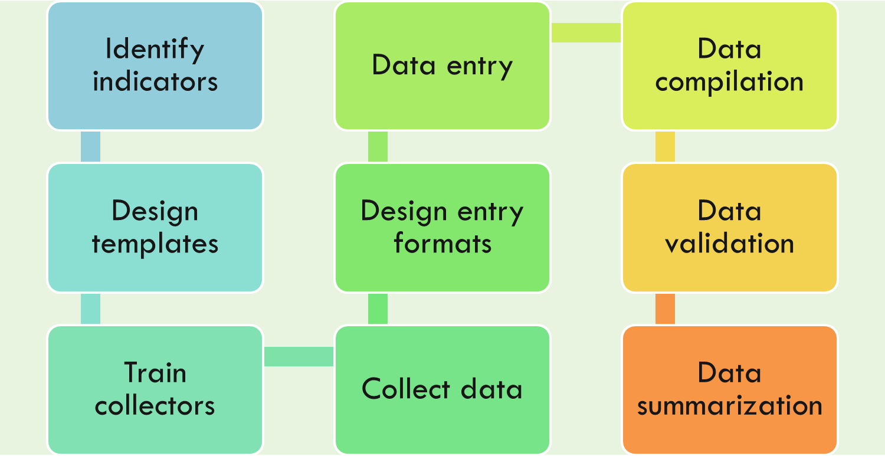

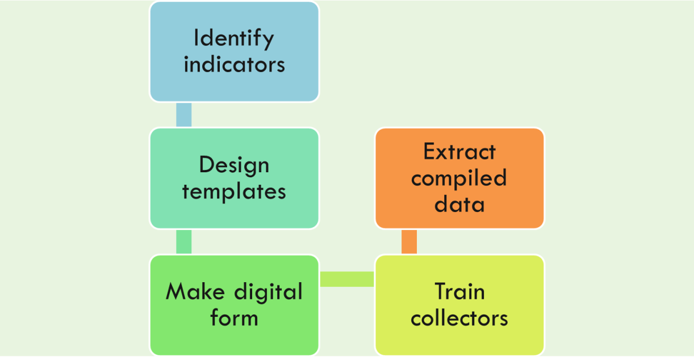***Fig. 1a – Steps required for paper based data collection***

***Fig. 1b – Steps required for digital data collection***

***Data storage and retrieval:*** Data that is collected digitally is free from regular damage, as opposed to paper-based surveys which can be easily destroyed by water, rain, fires among others. Data is usually freely accessible for download since it is stored in the server. For most digital data collection software, internet access is not required during the process of data collection, but only for sending the data to the server.

***Geo-tagging of samples:*** Digital data collection platforms allow for collection of GPS coordinates of the observation units (e.g. farm households or plots) ensuring that it is possible to link attribute data to their corresponding spatial data. Units geo-tagged can be used for better targeting of project interventions vis-a-vis available infrastructure.

***Environmental conservation issues:*** Needless to say, paper comes from trees, and the less paper we use, the better it is for the environment.

## **4.2 Available Tools & Platforms**

As the number of smart devices in use grows, the amount of data collected digitally is multiplying exponentially. The size of the digital data universe will increase 40 percent each year into the next decade. Keeping this growth trend in mind, many developers have come up to provide solutions for digital data collection. One such tool is web based system. Forms are developed within the website or web portal to collect data from the intended users with scope of proper validation of the entered data. Data can be captured either in online or offline mode (a template in excel can be provided to download and fill). However, internet connectivity with required bandwidth is must to upload information in the server. With the growing number of smart phone users, apps are increasingly become popular as a medium of data exchange in today’s world of digital communication. Hundreds of apps are already available now, each with its own set of benefits and shortcomings.

**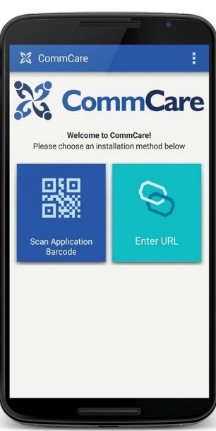

**

We need to be very selective while choosing among them based on our available resources, skills and needs.

## 

## ***4.3 Open Data Kit (ODK) – Basic Components***

Open Data Kit (ODK) is a suite of open source tools that help organizations collect and manage data.** Basically, ODK is a mobile smartphone based data collection app. It has three basic components to manage survey design, data collection & data aggregation. There are two ways of making forms using ODK: ODK Build and ODK XLSForm.

**ODK Build** (https://build.opendatakit.org/): It is a drag-and-drop form designer (only online).

**ODK XLSForm**: It is an Excel-based form designer (XLSForm Online, XLSForm Offline). In XLSForm, there are two options to design the forms: i) XLSForm online (https://opendatakit.org/xlsform/) and ii) XLSForm offline (https://github.com/opendatakit/xlsform-offline/releases/tag/v1.9.0).

**ODK Collect:** It is openly available and can be downloaded from Google Play Store like we do for Facebook, Ola, Cricbuzz, Snapdeal, etc. The app is android based and can be downloaded on devices supporting android operating system. Survey form is downloaded in ODK Collect and is then used for data collection and sending the filled-in forms to aggregate.

**ODK Aggregate:** It automatically compiles data received from ODK Collect. Compiled data can be exported in useful formats (CSV, JSON & KML) based on what tools are going to be used for analysis. Some sort of basic analysis can be performed at ODK Aggregate itself. These features include making bar graphs, pie charts and GPS based mapping. These analyses are single click based commands, very user friendly and are quite attractive feature incorporated in ODK.

## ***4.4 Why ODK?***

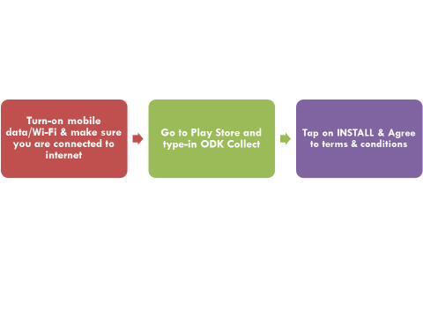ODK is an open source app, which means that source code is freely available and may be modified by interested user. ODK encourages users to customise the application based on their requirement. It works in low-tech and low-resource settings. The programming part is also very simple. Anybody who uses MS Excel can quickly learn programming (how to design digital form in ODK). It is very user friendly. The smartphone users can learn to use this app within hours. It is being used widely across countries and is top rated by them. Even in areas without mobile or internet networks, data can be collected first and then transmitted to the database once users regain connectivity (either on the same day or after a week or a month). CSISA has been using ODK for indicator tracking for last couple of years and has found this tool very relevant, efficient, accurate and reliable.

***4.5 ODK Collect App***

You can get this app on your android based smartphone by following few simple steps:

******Appearance of ODK Collect icon on your screen means it is installed and ready to use.

## ***4.6Operational Aspects of ODK***

All three components of ODK (Build, Collect & Aggregate) are integrated in a way that they offer a complete solution for data digitization. Internet connectivity is required to complete few steps only. For example, it is required while downloading the app, downloading the survey form on app and sending the finalized form to ODK aggregate. Internet is not required while collecting data using the ODK Collect. That is the most convenient option ODK offers.

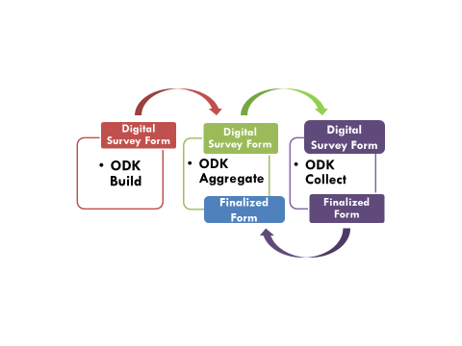Digital survey form designed using ODK Build is uploaded on ODK Aggregate from where it can be downloaded on ODK Collect for use. After filling-in survey form, user can send the same to ODK Aggregate where it gets compiled automatically. User can fill-in several forms and save it in the device. S/he can send all forms simultaneously whenever s/he gets connected to internet. Users are concerned to ODK Collect only. The other two components are taken care of by backend technical expert.

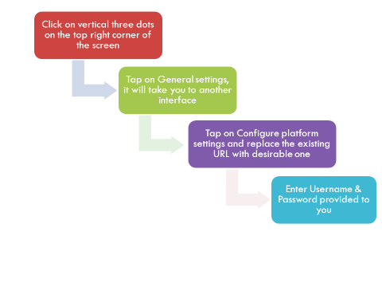An important step before using ODK Collect is to change app URL from default interface and link it to our URL/server. This change allows us to customize the app for getting only those survey forms designed by us and creating our own space for data compilation. Steps to configure your platform setting have been shown above.

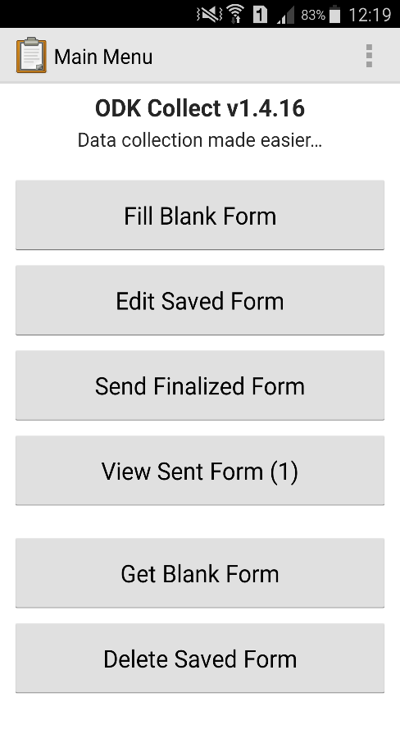ODK Collect offers six options for data collectors.

*Get Blank Form* – To download digital survey form available on ODK Aggregate

*Fill Blank Form* – Fill-in survey form to collect data as per prescribed format

*Edit Saved Form* – Make changes/addition in already filled-in survey forms

*Send Finalized Form* – To send finalized survey form to aggregate for compilation

*View Sent Form* – See sent forms to check whether they reached destination or not

*Delete Saved Form* – Allow deletion of Blank Form & Saved Form if users feel they are no more relevant/required.

## ***4.7 ODK – Creating Self-reliant System***

To completely integrate ODK in your own system (Design, Collect & Aggregate) wherein you don’t require external support, some degree of technical expertise and familiarity with the internet is required. But, before you plan to upgrade, the personnel should have sufficient knowledge and experience to handle ODK Collect. Once, these personnel become confident enough in collecting data using ODK Collect, we can support and handhold creating your own digital ecosystem. Designing survey forms is a sort of programming language that can be learned by people good at using MS Excel. Handling ODK Aggregate requires simple computer related technical skills that can be either learned through online tutorials or trained externally. An organization with this backend technical person would be able to manage ODK independently given their operational team is trained and motivated enough to collect data using the same app (ODK Collect).

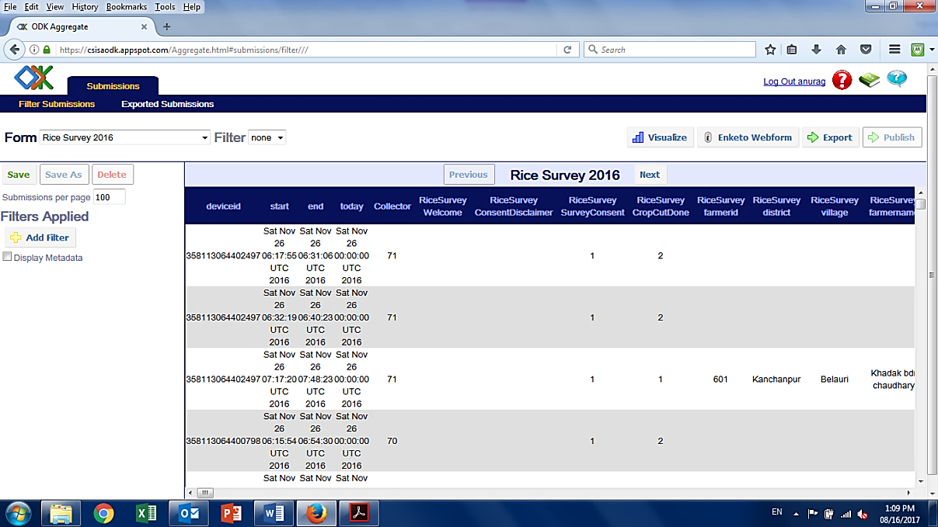***4.8 Extracting Dataset***

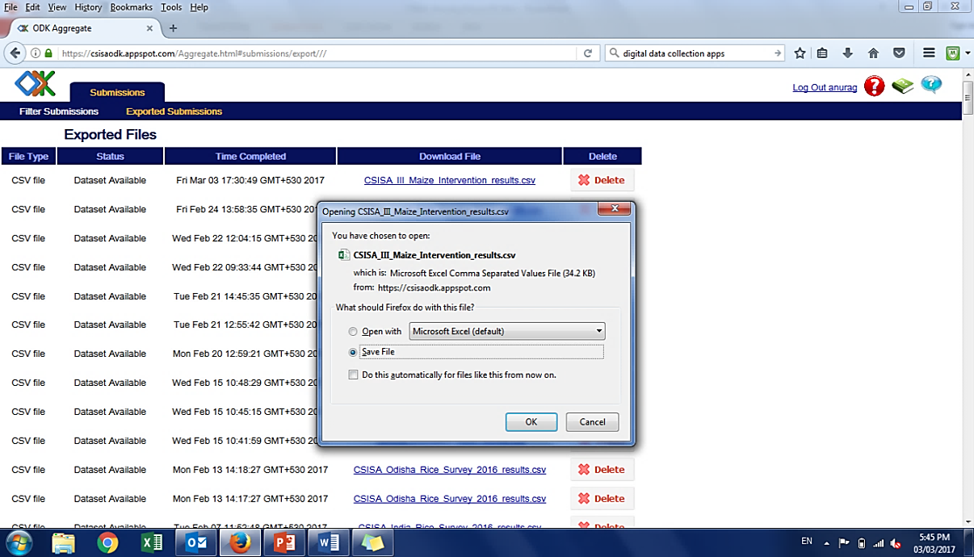After completion of data collection, the compiled dataset of the survey can be extracted from ODK server. Data extraction is a simple and easily executable task that can be performed any time after the collection process starts. Staffs having access of server should log-in and choose dataset from the FORM box option on the left of the screen. Once a particular dataset (Form) is selected, tap on EXPORT button on the right side of the screen. ODK server starts generating desired dataset for you. Once, it says ‘Dataset Available’, click on the link to download.

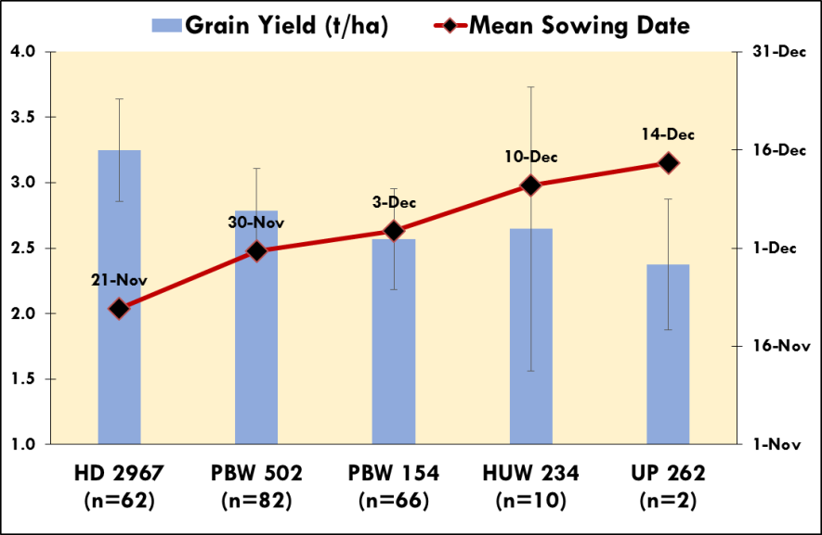***4.9 Data Diagnostics***

MS Excel provides enough features to diagnose such datasets. We can see the wheat planting pattern, varietal performance, varietal distribution, etc. for a district using MS Excel. An example of diagnostics done for similar dataset is as follows:

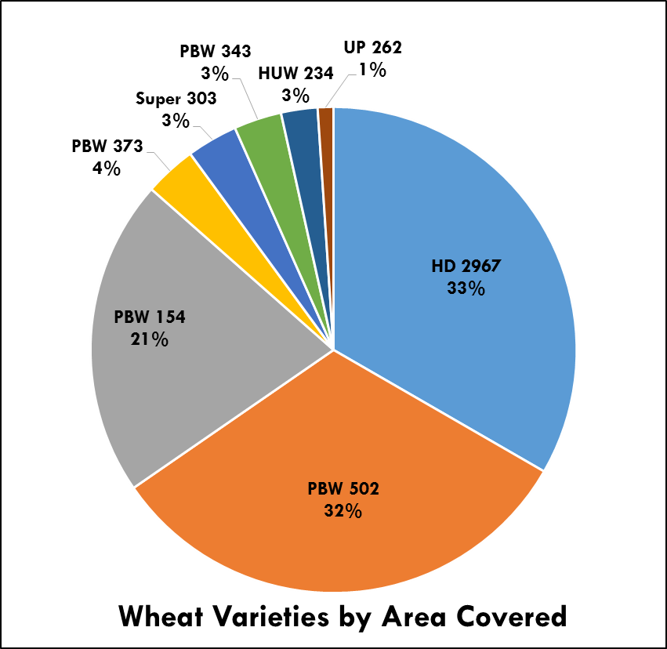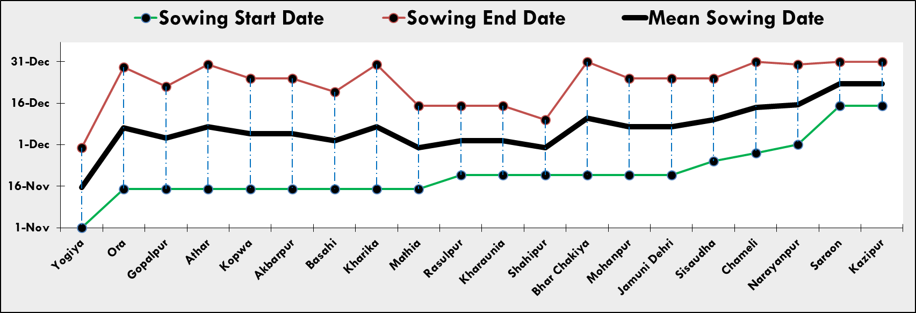

This type of analysis helps understand larger picture of a district. Such data driven findings can also form the basis of refining state programming and can moreover help streamline our internal learning process.

# 

# ***5. Database Management***

Database management is one the important components of MLE. It helps in easy tracking of database in future and avoids loss. To achieve this, two aspects need to be followed:

* Folder & file naming convention
* Systematic storage & sharing of data

## ***5.1 Folder & File Naming***

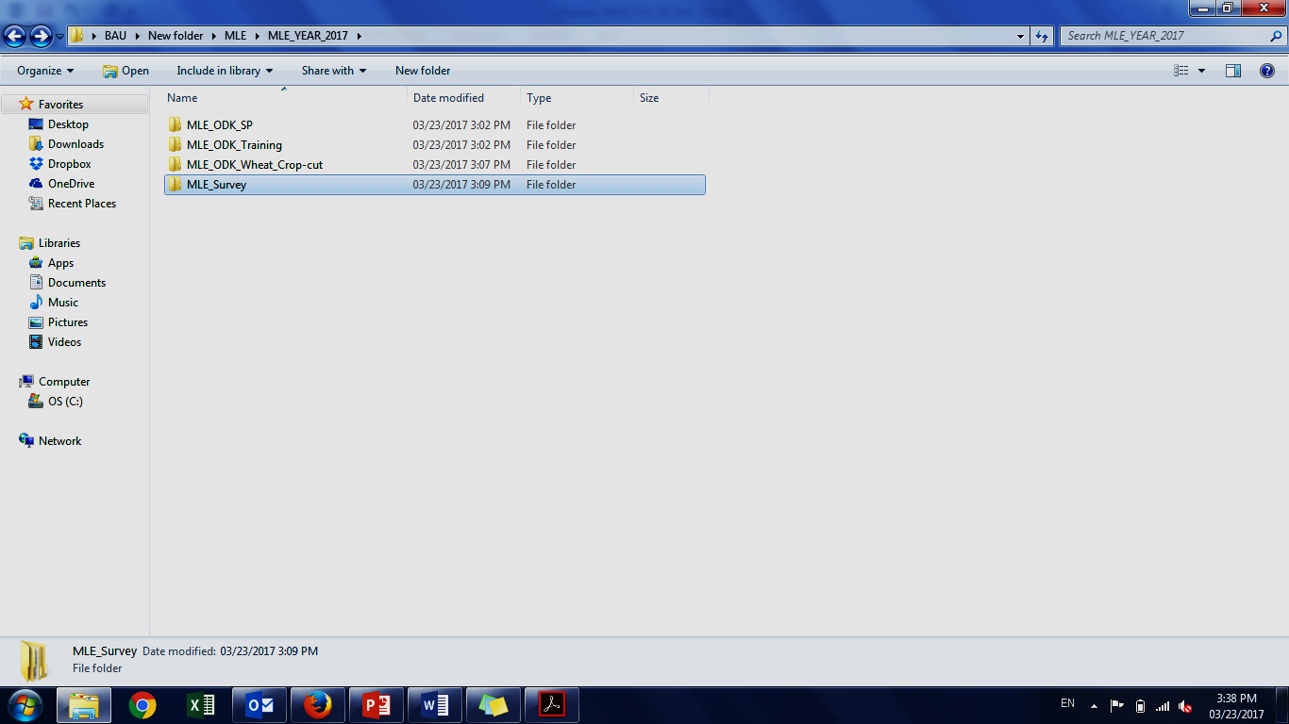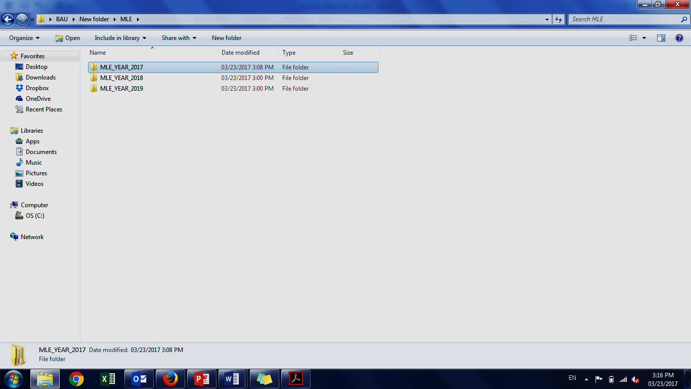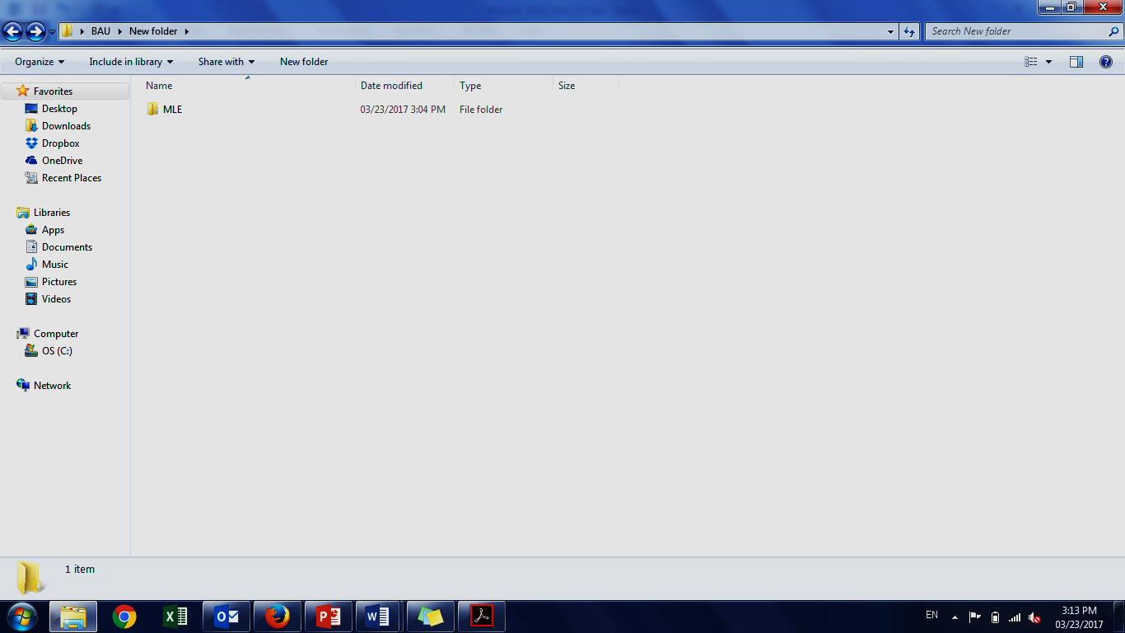It is a process of naming your data files & folder in a way that it reflects ‘what is inside’.

## 

## ***5.2. Database Storage & Sharing***

Data is the biggest asset of any organization. So, to protect your data from loss, options are:

Keeping data sets at multiple locations – The preferred option is transferring your data folder to external hard disc periodically and keeping the same at safe place.

Sharing through personal cloud storage service (online backup service) – The other and better option is to use Google Drive or Dropbox.

It protects your data from all sort of physical damage. It is linked to your email and it allows you to store and share your data with concerned persons.

These systems work with ‘drag-drop’ action and are very user friendly.

***Annex*** ***I: Steps to get digital survey form in ODK Collect***